Project Title: Customer Support Case Management

**Project Overview:**

Companies handling large volumes of customer issues often face delays in resolving cases due to manual processes. Customers want faster resolution and clear communication about their issues, while managers need real-time insights into support performance. A Salesforce-based Case Management system can automate case assignment, send timely alerts, escalate unresolved issues, and provide dashboards for monitoring. This improves customer satisfaction and optimizes support team efficiency.

**Objectives**

# Automate assignment of cases to support agents based on type.

# Escalate unresolved cases to managers within SLA time.

# Send email notifications to case owners and managers.

# Provide reports and dashboards to track support performance.

# Improve response time and customer satisfaction.

# Phase 1: Problem Understanding & Industry Analysis

**Requirement Gathering**

* **Stakeholders** – Customers, support agents, team managers, and admins.
* **Customer Needs** – Simple way to raise complaints/issues, receive timely updates, and faster resolution.
* **Support Staff Needs** – Tools to automatically receive assigned cases, track progress, and escalate unresolved cases.
* **Manager Needs** – Dashboards to track open cases, escalations, and team performance.

**Stakeholder Analysis**

## Customers → End users raising issues (technical, billing, general queries).

## Support Agents → Handle assigned cases, update progress, and resolve issues.

## Managers → Monitor escalated cases, overall support performance, and SLA compliance.

## Admins → Configure case rules, automation flows, and maintain system.

**Business Process Mapping**

## Customer raises a Case in Salesforce (via portal/email).

## Case is automatically assigned to correct queue based on Case Type.

## Support agent works on resolving the case.

## Email notifications sent to customer and agent on creation/updates.

## If unresolved within 48 hours, case status updated to Escalated and manager notified.

## Managers can take proactive actions on escalated cases.

## Use Cases

* **Case Creation & Assignment** – Customers log issues, cases auto-assigned to queues (Technical/Billing/General).
* **Notifications** – Email alerts sent to customers & agents on case creation and escalation.
* **Escalations** – Cases not closed within SLA (48 hrs) auto-escalated and reassigned.
* **Case Tracking** – Support team updates status; customers can track case progress.
* **Performance Dashboards** – Managers receive an email notification when a case escalates

**AppExchange Exploration**

* Email-to-Case Premium – Advanced automation for customer email-to-case conversions.
* Service Cloud Voice – Integrates telephony with case management for real-time support.
* Survey Force – Collects customer feedback post-case resolution to measure satisfaction.
* Slack Integration for Service Cloud or Omni-Channel to show research.

# Phase 2: Org Setup & Configuration

# Salesforce Setup

# Sign up / log in to Salesforce Developer Edition.

# 

# Check available licenses:

# Go to Setup → Company Information → User Licenses.

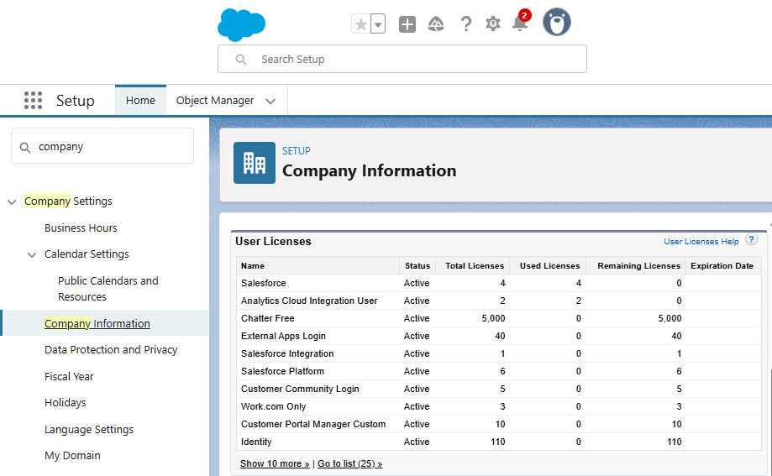**Ensure System Administrator access.**

### My Domain Setup:

### Setup → My Domain → Register Domain → Deploy.

### 

### Business Hours & Holidays:

### Setup → Business Hours → New.

### 

### User Setup:

### Setup → Users → New User → Fill details for Alice & Meera → Assign Standard User Profile.

### 

### **Phase 3 – Data Modeling & Case Object Configuration**

### Navigate: Setup → Object Manager → Case.

### 

### Add / verify fields: Case Type, Status.

### 

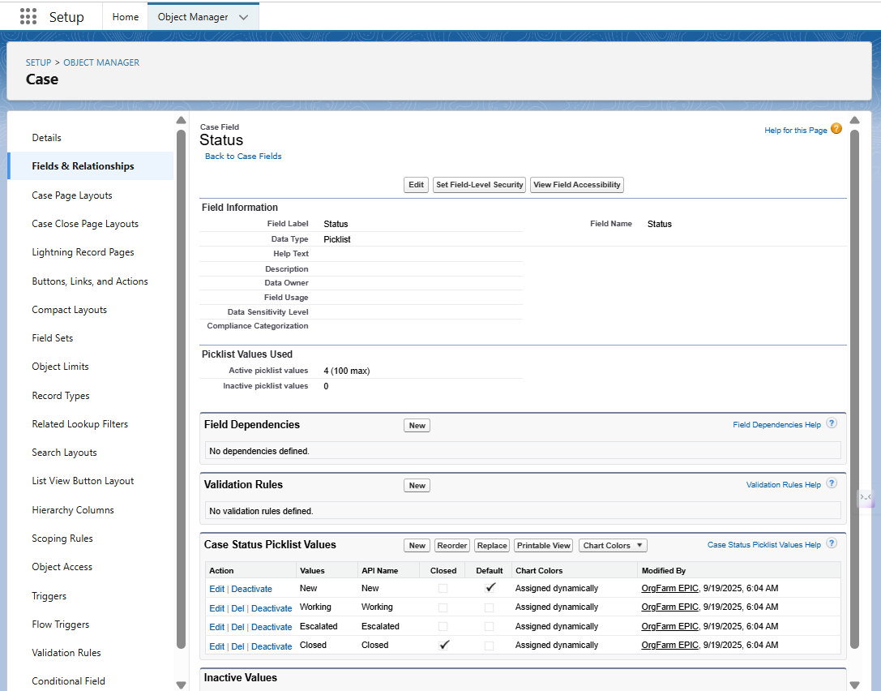

### Create Queue:

### Setup → Queues → New → Name: Support Agent Queue → Add Alice.

### 

### **Phase 4 – Assignment Rules**

### Navigate: Setup → Case Assignment Rules → New Rule.

### Rule Name: Support *Case Assignment* → Activate.

### 

### Add Rule Entry:

### Order = 1

### Criteria: Case Type = Technical

### Assign To: Queue Support Agent

### 

### Test Case:

### App Launcher → Service → Cases → New Case → Select Type: Technical.

### Confirm Owner = Alice.

### 

### **Phase 5 – Process Automation (Flows & Email Notifications)**

### Step A – Email Templates

### Navigate: Setup → Classic Email Templates → New Template.

### Create:

### Case Created – Notify Owner

### Case Escalated – Notify Manager

### 

### Step B – Email Alerts

### Navigate: Setup → Email Alerts → New.

### Configure:

### Case Created – Notify Owner → Recipient: Case Owner

### Case Escalated – Notify Manager → Recipient: Meera Singh

### 

### Step C – Record-Triggered Flow (Escalation)

### Navigate: Setup → Flows → New Flow → Record-Triggered Flow.

### Object: Case → Trigger After Save.

### Immediate Action: Send Email Alert (Case Created – Notify Owner).

### Scheduled Path: 48 Hours (use 1 min for testing).

### Condition: Case Status != Closed

### Action: Update Case Status = Escalated → Send Email Alert (Notify Manager)

### 

### **Phase 6 – Reports & Dashboard**

### Reports

### Navigate: App Launcher → Reports → New Report → Cases.

### Create reports:

### Open Cases by Owner (filter: Status != Closed).

### Cases by Type (Group by Type).

### Escalated Cases (filter: Status = Escalated).

### 

### Dashboard

### Navigate: App Launcher → Dashboards → New Dashboard.

### Add components:

### Bar Chart: Open Cases by Owner

### Pie Chart: Cases by Type

### Metric: Escalated Cases

### 

### **Phase 7 – Testing**

### Case Assignment Test:

### Create Case → Type = Technical → Owner = Alice(Queue – Support Agent)

### 

### Check email notification.

### Escalation Test:

### Create Case → Leave open → Wait 1 min.

### Status = Escalated → Manager receives email.

### 

### Reports & Dashboard Test: Validate open, escalated, and type reports.

### **Phase 8 – Manual Report Exports**

### Navigate: **App Launcher → Reports → [Select Report] → Export**.

### Export format: .xls / .csv for:

### Open Cases by Owner

### Cases by Type

### Escalated Cases

### Save exported files locally.

### **Phase 9 – Workbench Export to GitHub**

### Navigate: **Workbench → Login → Environment: Sandbox/Production**.

### 

### Go to **Migration → Retrieve / Export Metadata**.

### 

### Select **Reports / Dashboards / Email Templates** → Export as .zip.

### Push exported files to GitHub repository:

### git init

### git add .

### git commit -m "Initial Salesforce Reports export"

### git push origin main

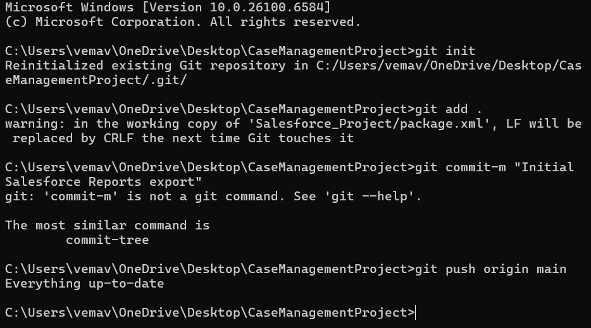

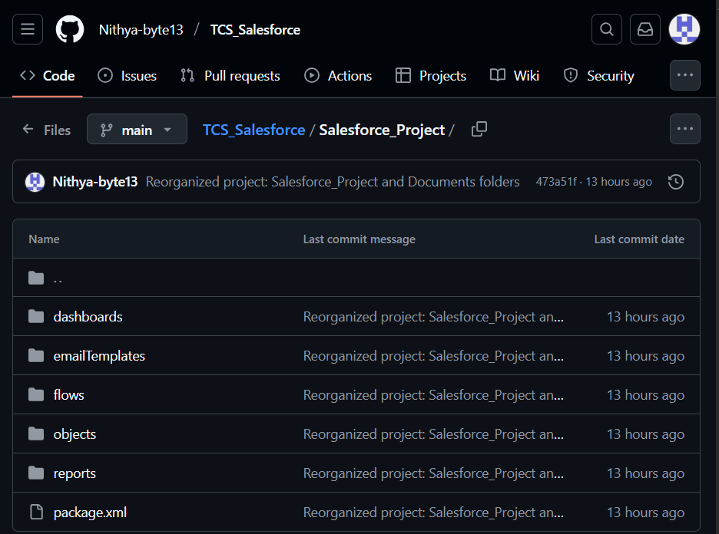

### **Phase 10 – Data Management & Email Verification**

### **Email Deliverability:** Setup → Email → Deliverability → All Email (sandbox).

### **Verify User Emails:** Setup → Users → [Select User] → Confirm email is verified.

### **Test Emails:** Trigger email alerts via Case creation or escalation → check inbox (spam/promotions if necessary).

### **Email Log Files (Admin Debugging):** Setup → Email Log Files → Request log → Verify emails sent.

### **Security Review:** Setup → Sharing Settings → Confirm dashboard/report access by roles.

### **Final Dashboard & Report Check:** Confirm metrics display correctly.

**Final Result**

### This project demonstrates **end-to-end Salesforce Customer Support Case Management** using **declarative tools only**:

### Assignment Rules & Queues

### Record-Triggered Flows & Email Alerts

### Reports & Dashboards

### Metadata Export (Manual & Workbench → GitHub)

### Testing & Email Verification

### The solution ensures SLA compliance, boosts visibility, and improves customer satisfaction.

### 